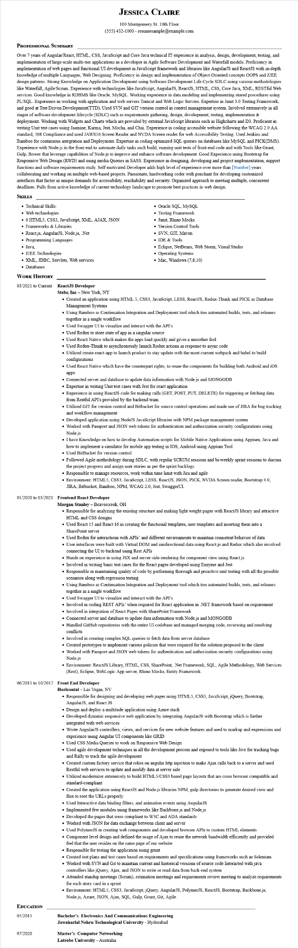
JESSICA CLAIRE
100 Montgomery St. 10th Floor
(555) 432-1000 - resumesample@example.com
PROFESSIONAL SUMMARY
Over 7 years of Angular/React, HTML, CSS, JavaScript and Core Java technical IT experience in analysis, design, development, testing, and implementation of large-scale multi-tier applications as a developer in Agile Software Development and Waterfall models. Proficiency in implementation of web pages and functional UI development in JavaScript framework and libraries like AngularJS and ReactJS with in-depth knowledge of multiple Languages, Web Designing. Proficiency in design and implementation of Object-Oriented concepts OOPS and J2EE design patterns. Strong Knowledge on Application Development using Software Development Life Cycle SDLC using various methodologies like Waterfall, Agile/Scrum. Experience with technologies like JavaScript, AngularJS, ReactJS, HTML, CSS, Core Java, XML, RESTful Web services. Good knowledge in RDBMS like Oracle, MySQL. Working experience in data modeling and implementing stored procedures using PL/SQL. Experience in working with application and web servers Tomcat and Web Logic Servers. Expertise in Junit 3.0 Testing Framework, and good at Test Driven Development(TTD). Used SVN and GIT version control in control management system. Involved extensively in all stages of software development lifecycle (SDLC) such as requirements gathering, design, development, testing, implementation & deployment. Working with Widgets and Charts which are provided by external JavaScript libraries such as Highcharts and D3. Proficient in writing Unit test cases using Jasmine, Karma, Jest, Mocha, and Chai. Experience in coding accessible website following the WCAG 2.0 AA standard, 508 Compliance and used JAWS16 Screen Reader and NVDA Screen reader for web Accessibility Testing. Used Jenkins and Bamboo for continuous integration and Deployment. Expertise in coding optimized SQL queries on databases like MySQL and PICK(DMS). Experience with Node.js in the front end to automate daily tasks such build, running unit tests of front-end code and with Tools like Grunt, Gulp, Bower that leverage capabilities of Node.js to improve and enhance software development. Good Experience using Bootstrap for Responsive Web Design (RWD) and using media Queries in SASS. Experience in designing, developing and project implementation, support functions and software requirements study. Self-motivated Developer adds high level of experience over more than [Number] years collaborating and working on multiple web-based projects. Passionate, hardworking coder with penchant for developing customized interfaces that factor in unique demands for accessibility, reachability and security. Organized approach to meeting multiple, concurrent deadlines. Pulls from active knowledge of current technology landscape to promote best practices in web design.
SKILLS
• Technical Skills:
• Web technologies
⚫ 0 HTML5, CSS3, JavaScript, XML, AJAX, JSON
• Frameworks & Libraries
• React.js, AngularJS, Node.js, .Net
• Programming Languages
• Java,
• J2EE Technologies
• XML, JDBC, Servlets, Web services
• Databases
WORK HISTORY
03/2021 to Current ReactJS Developer Stebr, Inc - New York, NY
• Oracle SQL, MySQL
• Testing Framework
• Junit, Rhino Mocks
• Version Control Tools
• SVN, GIT, Maven
• IDE & Tools
• Eclipse, NetBeans, Web Storm, Visual Studio
• Operating Systems
• Mac, Windows (7,8,10)
• Created an application using HTML 5, CSS3, JavaScript, LESS, ReactJS, Redux-Thunk and PICK as Database Management Systems
• Using Bamboo as Continuation Integration and Deployment tool which ties automated builds, tests, and releases together in a single workflow
• Used Swagger UI to visualize and interact with the API's
• Used Redux to store state of app in a singular source
• Used React Native which makes the apps load quickly and gives a smoother feel
• Used Redux-Thunk to asynchronously launch Redux actions in response to async code
• Utilized create-react-app to launch product to stay update with the most current webpack and babel to build configurations
• Used React Native which have the counterpart rights, to reuse the components for building both Android and iOS apps
• Connected server and database to update data information with Node.js and MONGODB
• Expertise in writing Unit test cases with Jest for react application
• Experience in using ReactJS code for making calls (GET, POST, PUT, DELETE) for triggering or fetching data from Restful API's provided by the backend team
• Utilized GIT for version control and Bitbucket for source control operations and made use of JIRA for bug tracking and workflow management
• Developed application using NodeJS JavaScript libraries with NPM package management system
• Worked with Passport and JSON web tokens for authentication and authorization security configurations using Node.js
• I have Knowledge on how to develop Automation scripts for Mobile Native Applications using Appium, Java and how to implement a simulator for mobile app testing in IOS, Android using Appium Tool
• Used BitBucket for version control
• Followed Agile methodology during SDLC, with regular SCRUM sessions and bi-weekly sprint sessions to discuss the project progress and assign user stories as per the sprint backlogs
• Responsible to manage resources, work within time limit with Jira and agile
• Environment: HTML5, CSS3, JavaScript, LESS, ReactJS, JSON, PICK, NVDA Screen reader, Bootstrap 4.0, JIRA, Bitbucket, Bamboo, NPM, WCAG 2.0, Jest, SwaggerUI.
01/2020 to 03/2021 Frontend React Developer
Morgan Stanley - Beavercreek, OH
• Responsible for analyzing the existing structure and making light weight pages with ReactJS library and attractive HTML and CSS designs
• Used React 15 and React 16 in creating the functional templates, user templates and inserting them into a SharePoint server
• Used Redux for interactions with APIs and different environments to maintain consistent behavior of data
• User interfaces were built with Virtual DOM and unidirectional data using React.js and Redux which also involved connecting the UI to backend using Rest APIs
• Hands on experience in using JSX and server-side rendering for component view using React.js
• Involved in writing basic test cases for the React pages developed using Enzyme and Jest
• Responsible in maintaining quality of code by performing thorough and proactive unit testing with all the possible scenarios along with regression testing
• Using Bamboo as Continuation Integration and Deployment tool which ties automated builds, tests, and releases together in a single workflow
• Used Swagger UI to visualize and interact with the API's
• Involved in coding REST APIs when required for React application in .NET framework based on requirement
• Involved in integration of React Pages with SharePoint Framework
• Connected server and database to update data information with Node.js and MONGODB
• Handled GitHub repositories with the entire UI codebase and managed merging code, reviewing and resolving conflicts
• Involved in creating complex SQL queries to fetch data from server database
• Created prototypes to implement various policies that were required for the solution proposed to the client
• Worked with Passport and JSON web tokens for authentication and authorization security configurations using Node.js
• Environment: ReactJS Library, HTML, CSS, SharePoint, Net Framework, SQL, Agile Methodology, Web Services (Rest), Eclipse, WebLogic App server, Rhino Mocks, Entity Framework.
06/2015 to 10/2017 Front End Developer
Horizontal - Las Vegas, NV
EDUCATION
05/2015
• Responsible for designing and developing web pages using HTML5, CSS3, JavaScript, jQuery, Bootstrap, AngularJS, and React JS
• Design and deploy a multitude application using Azure stack
• Developed dynamic responsive web application by integrating AngularJS with Bootstrap which is further integrated with web services
• Wrote AngularJS controllers, views, and services for new website features and used to markup and expressions and experience using Angular UI components like GRID
• Used CSS Media Queries to work on Responsive Web Design
• Used agile development techniques in all the development process and exposed to tools like Jive for tracking bugs and Rally to track the agile development
• Created custom factory service that relies on angular http injection to make Ajax calls back to a server and used Restful web services to update and modify data at server side
• Utilized modernizer extensively to build HTML5/CSS3 based page layouts that are cross browser compatible and standard-compliant
• Created the application using ReactJS and Node.js libraries NPM, gulp directories to generate desired view and flux to root the URLs properly
• Used Interactive data binding filters, and animation events using AngularJS
• Implemented few modules using frameworks like Backbone.js and Node.js
• Developed the pages that were compliant to W3C and ADA standards
• Worked with JSON for data exchange between client and server
• Used PolymerJS in creating web components and developed browser APIs to custom HTML elements
• Component level design and defined the usage of Ajax to reuse the network bandwidth efficiently and provided feel that the user resides on the same page of our website
• Responsible for testing the application using grunt
• Created test plans and test cases based on requirements and specifications using frameworks such as Selenium
• Worked with SVN and Git to maintain current and historical versions of source code Interacted with java controllers like jQuery, Ajax, and JSON to write or read data from back-end system
• Attended standup meetings (Scrum), estimation meetings and requirements review meeting to analyze requirements for each story card in a sprint
• Environment: HTML5, CSS3, JavaScript, jQuery, AngularJS, PolymerJS, ReactJS, Bootstrap, Backbone.js, Node.js, Azure, JSON, Ajax, SQL, Gulp, Grunt, Git, Agile.
Bachelor's: Electronics And Communications Engineering Jawaharlal Nehru Technological University - Hyderabad
07/2020
Master's: Computer Networking
Latrobe University - Australia

